Creating the Collection Class (Properties)

Creating the Collection Class 1
Creating the Properties 4

Creating the Collection Class
The final class to complete is the class clsAddressCollection.

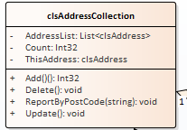

As always start with the simple stuff first.

Create the test class tstAddressCollection...

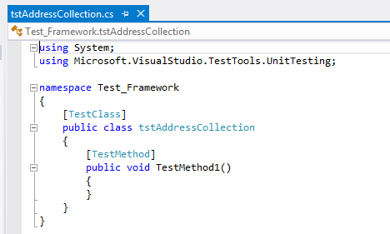

Next create a test to see if we can create an instance of the class...

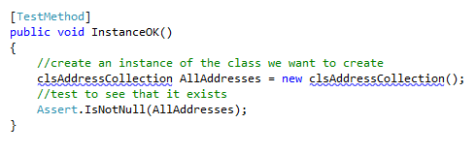

Watch the test fail...

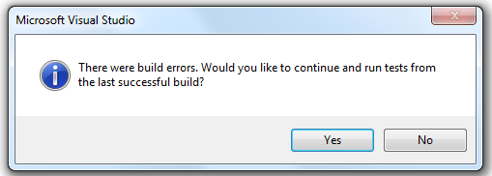

Now fix the test...

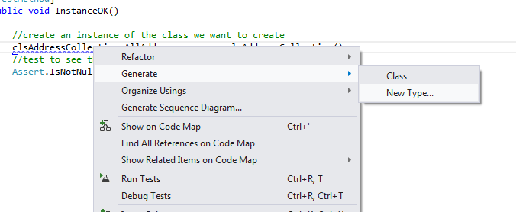

Making sure the new class file is created in the class library...

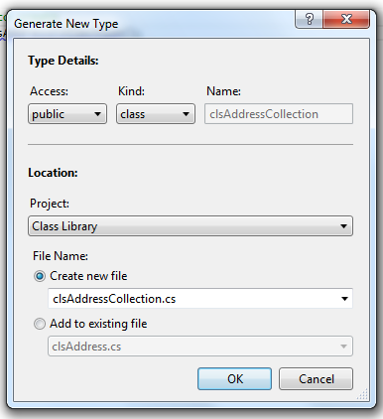

Then see the test pass.

Creating the Properties

Next we create the properties for the class.

It doesn't matter at this stage what order we create them in so we will use the order on the class diagram:

- AddressList
- Count
- ThisAddress

We need to first import into the class file the .NET library for handling collections...

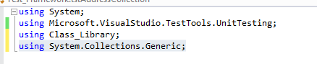

Now we may create the test for the AddressList property...

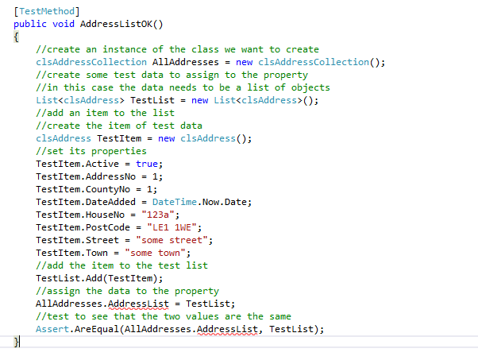

As usual the test should fail...

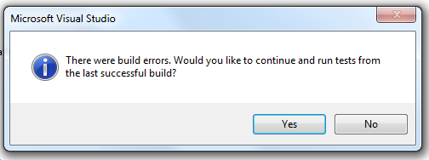

Fix the test to see it pass...

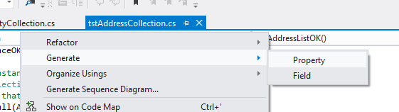

Here are the remaining tests for the other two properties....

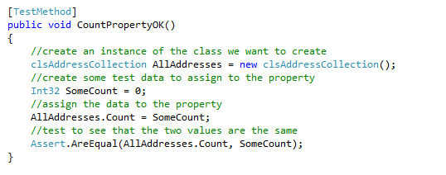
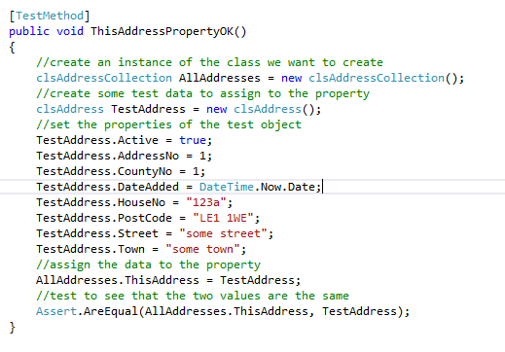
(I will let you sort out the code that generates the two properties!)

In a similar fashion to the code for clsCountyCollection we will set about creating the code that drives the Count property and the AddressList.

The AddressList will provide us with an indexed list of Address from the database table.

The Count property will always tell us how many addresses there are in this list.

We have already created the tests to make sure the two properties exist so let's spend a little time writing the code to create the functionality.

The first test we shall write is one to test if records can be added to the lists and the Count property correctly reports how many items are in the list.

Here is the test...

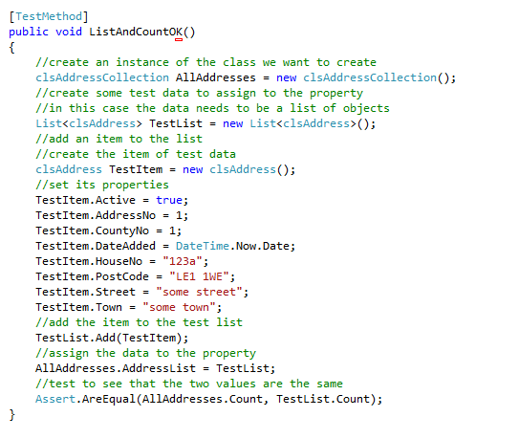

This should of course fail...

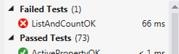

We now need to modify clsAddressCollection in very similar ways to how we modified clsCountyCollection.

We need to create a private data member for the list...

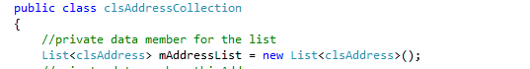

Next we need to expose the private data via the public property...

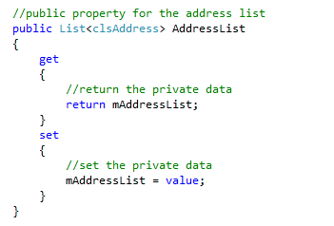

Once that is set up we may return the value of the Count property of the list as the value of our own Count property...

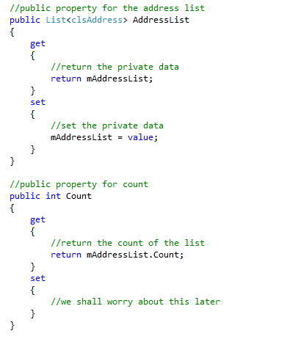

The test should now pass however the code is still rubbish!

The way we want this object to behave is that when we create an instance of the class the list is populated with all of the addresses in the database.

When we invoke the ReportByPostCode method...

The AddressList should only contain the addresses that match the post code supplied as a filter.

Let's create a test that gets us going in the right direction but will almost certainly be scrapped later.

Take a look at the following test...

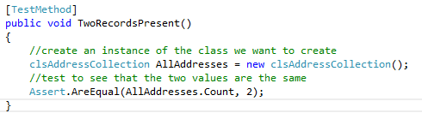
This test assumes that there are always two records in the AllAddresses object upon instantiation.

Clearly this test will fail (as always).

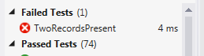

OK - so let's add some code to the class’s constructor.

Like so...

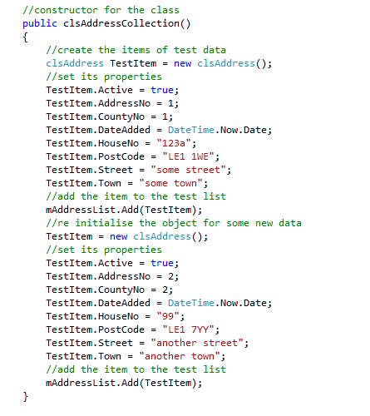

This adds two test records to the private list such that the test for two records now passes.

The bad news is that another test now fails...

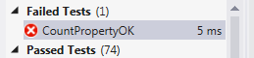

So what's the problem?

This test...

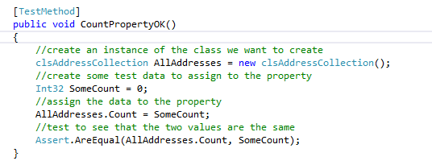

This test assumes that there will always be zero records in the list. This was true until we started adding code to the constructor just now.

We will apply a quick fix to this just to make the test pass like so...

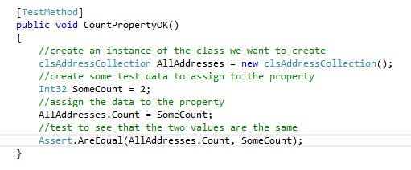

Honestly the code is still rubbish!

What we really want to be doing here is reading the data from the database rather than hard coding records like this.

Let's assume we have the following data...

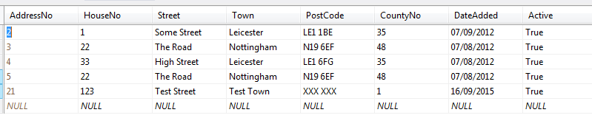

Along with the following stored procedure...

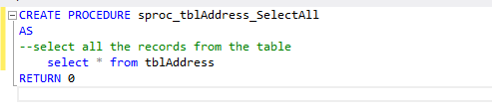
The following code should do the trick...

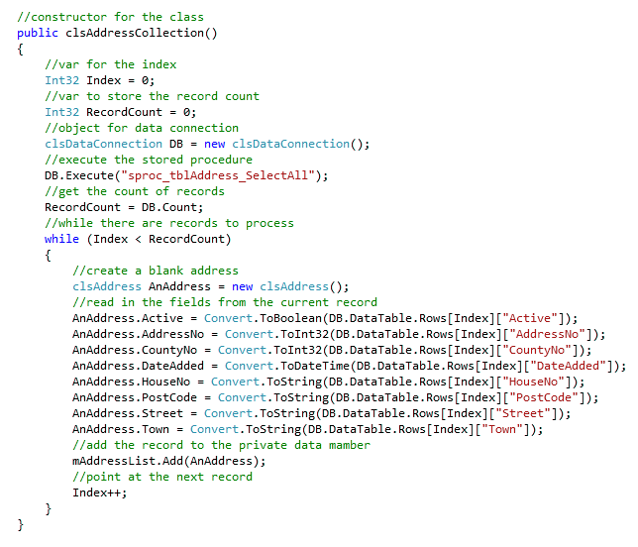

If you run your tests now you should see the following results...

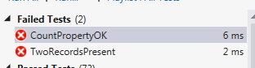

The first problem is that we no longer have a guaranteed two records...

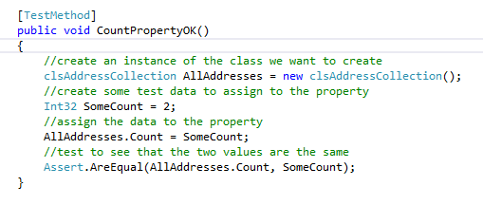

To be honest we could get rid of this test now as it is tested more thoroughly by this test...

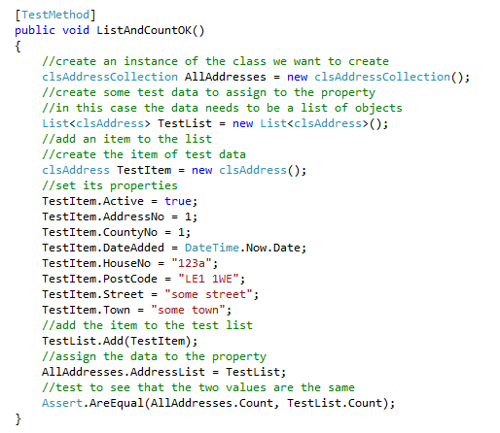

The following test...

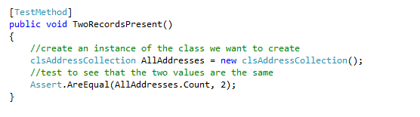Is also redundant and may be removed.

Unlike the testing in pathway 2 for clsCountyCollection which should always have 72 records we cannot predict how many records will be present in the collection clsAddressCollection.

Getting rid of the two tests above should mean that all of the tests pass and we now have a usable and tested collection class which is ready to be linked to the presentation layer.

In the smoke and mirrors prototype we need to add the following code to the form Default.aspx

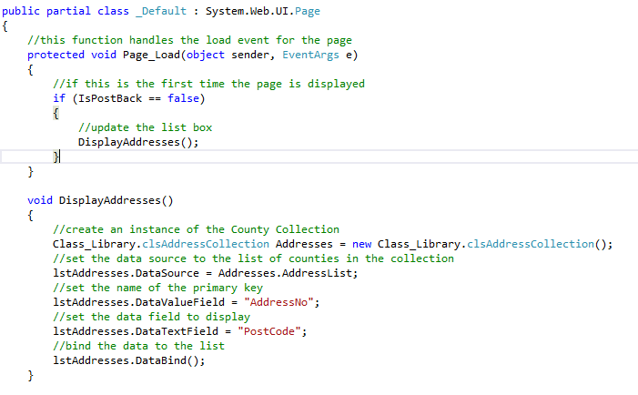

This code should update the list box with a list of post codes.

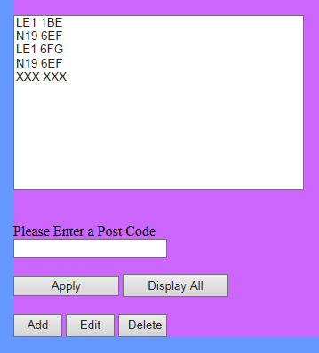

At this point it is worth thinking about how the property ThisAddress is going to work and how it relates to the methods Add, Update and Delete.

ThisAddress is an instance of clsAddress which we have already seen looks like this...

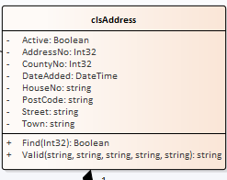

The find method allows us to search for a specific address based on its primary key value.

Assuming we have the following data...

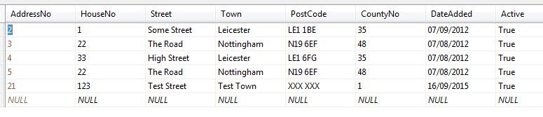

The following code...

clsAddress SomeAddress = new clsAddress();
SomeAddress.Find(3);

Would locate the second record in the list setting the values of the properties of SomeAddress to match the data stored in the record.

We can use the find method of clsAddress via any instances of clsAddressCollection.

Take a look at the following code...

clsAddressCollection AllAddresses = new clsAddressCollection();
AllAddresses.ThisAddress.Find(3);

This code would achieve exactly the same outcome as the previous code example.

Having the ThisAddress property allows us to point to any address we want to do something to, by searching on its primary key.

Once we are pointing at a specific record we may use Add, Update and Delete to change the data pointed to by ThisAddress.

So...

clsAddressCollection AllAddresses = new clsAddressCollection();
AllAddresses.ThisAddress.Find(3);
AllAddresses.Delete();

Would delete the address with the primary key value of 3.

Or...

clsAddressCollection AllAddresses = new clsAddressCollection();
AllAddresses.ThisAddress.Find(3);
AllAddresses.ThisAddress.HouseNo = "22";
AllAddresses.Update();

Would set the value of HouseNo for record 3 to "22".

Or...

clsAddressCollection AllAddresses = new clsAddressCollection();
AllAddresses.ThisAddress.Active = true;
AllAddresses.ThisAddress.CountyNo = 1;
AllAddresses.ThisAddress.DateAdded = DateTime.Now.Date;
AllAddresses.ThisAddress.HouseNo = "22";
AllAddresses.ThisAddress.PostCode = "LE1 1WE";
AllAddresses.ThisAddress.Street = "Some Street";
AllAddresses.ThisAddress.Town = "Some Town";
AllAddresses.Add();

Would add a new record based on the data we assigned to ThisAddress.

